4101 Shen Lake Drive
Harrisonburg, Virginia 22801

ANDY STELTEN, PGA
Teaching Professional
(22 years coaching experience)

US Kids Golf - Certified Coach
Member of the Positive Coaching Alliance
Eyeline Golf - Certified Putting Coach

The nearest facility with a US Kids Golf Certified Coaches is Orchard Creek in Waynesboro.

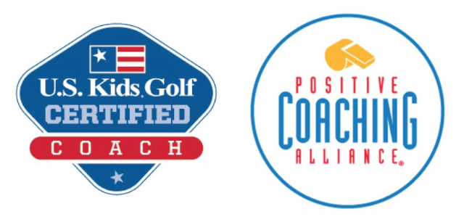

I am a PGA.coach Certified Coach and trained in the American (Athletic) Development Model.

This approach to Junior Golf Development is the wave of the future. When I combine what I have learned from the American (Athletic) Development Model, US Kids Golf, The Positive Coaching Alliance, the PGA Sports Academy and The First Tee over the years, I have developed an approach to teaching and coaching junior golfers that is very fun and effective.
JUNIOR GOLFER DEVELOPMENT

WHY A COACH MATTERS

Certainly one of the most often asked questions I get is: “How do I find the right instructor for my young golfer?” Every golf professional has their own unique personality and coaching methods that teach, motivate, encourage and inspire.

In my years of working with youth golfers, I agree with US Kids Golf Academy Directory, Jim Hardy, PGA. I too have found that nearly all young players respond best to coaches who incorporate these elements. I have a track record of success working with juniors for 20 years.

FUN
Good coaches make learning fun. Historically, golf instruction has not been fun. The best coaches create games and a social setting that not only makes the learning enjoyable, but the atmosphere as well. If it’s not fun, it becomes a chore. Kids don’t like chores.

PROPERLY FIT CLUBS
A good youth golf coach understands the importance of a club that fits the junior properly. If a student is doing a good job of applying their instruction, but has clubs that are not the correct length or are too heavy, results will likely be poor.

CHALLENGES and REWARDS
Kids love to receive incentives to improve and having measurable challenges is the best way to do that. Plus, a structured program, clearly communicated to both player and parent enables everyone to know how the player is doing. Parents and children deserve to see the yield of the time and money invested in junior golf coaching.

LEARNING THROUGH PLAY
In sports, a coach provides opportunities to get a player on the field of play, in our case a golf course. Getting kids on the course on holes that are the right length to help them shoot lower scores and have fun is a key element to fully engaging them in the game.

Learning the Game of Golf

New golfers learn best when engaged in a program that is clear, fun, easy to learn and rewarding. These essential elements are provided in the U.S. Kids Golf Player Pathway as a player advances from level to level as their skills improve.
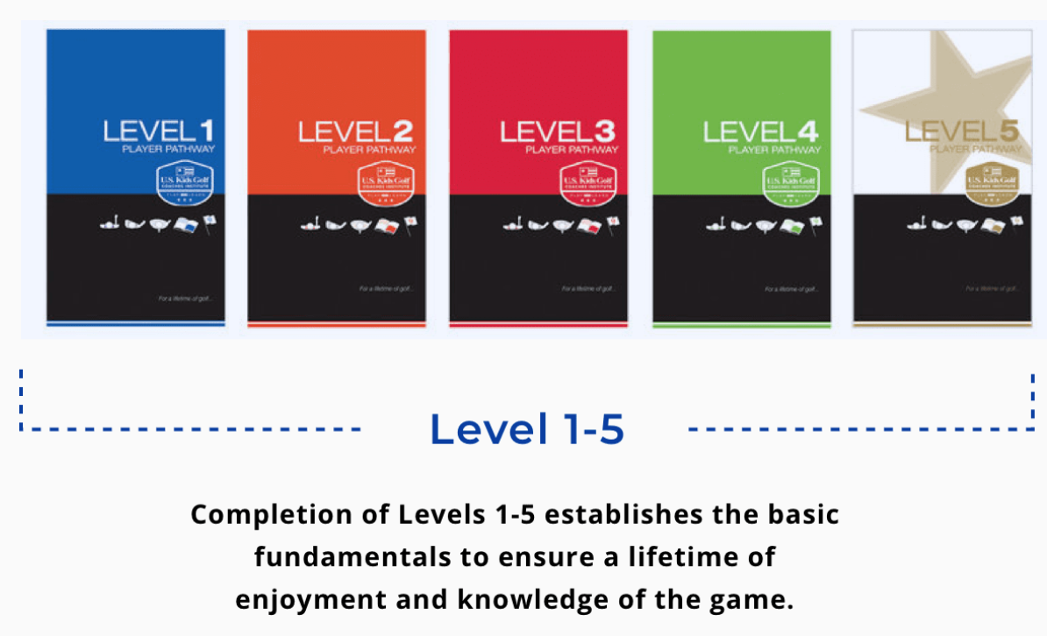
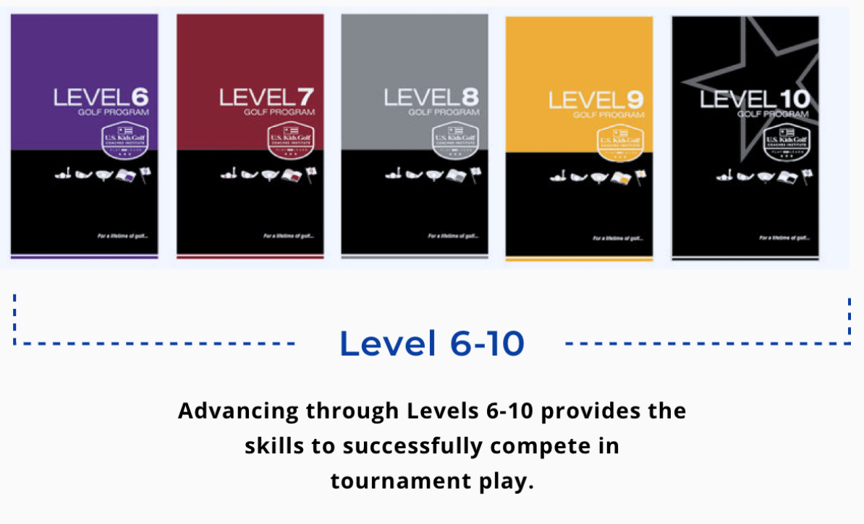

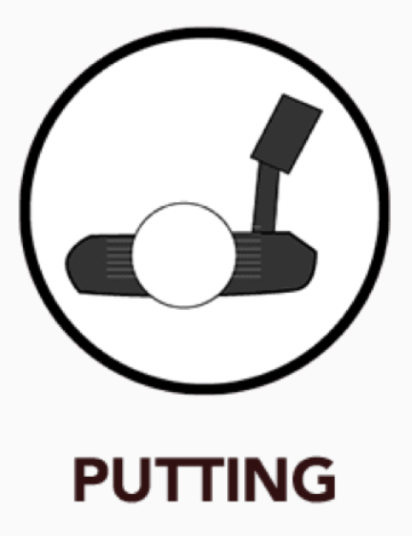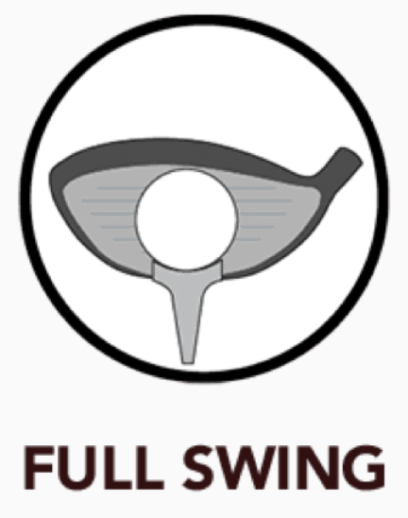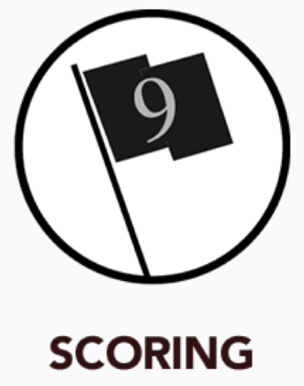

ABOUT THE PLAYER PATHWAY PROGRAM

The NEW U.S. Kids Golf Player Pathway consists of 10 Levels. As players advance from level to level, new forms are learned, skills improved and achievement pins are earned.

We are not currently employing this system at Lakeview Golf Club, but who knows in the future. The best of what this offers is a part of my approach to coaching junior golfers.

Completion of Levels 1 - 5 establishes the basic fundamentals to ensure a lifetime of enjoyment and knowledge of the game. Advancing through Levels 6 - 10 provides the skills to successfully compete in tournament play. In each level, there are five checkpoints in which achievement pins may be earned:

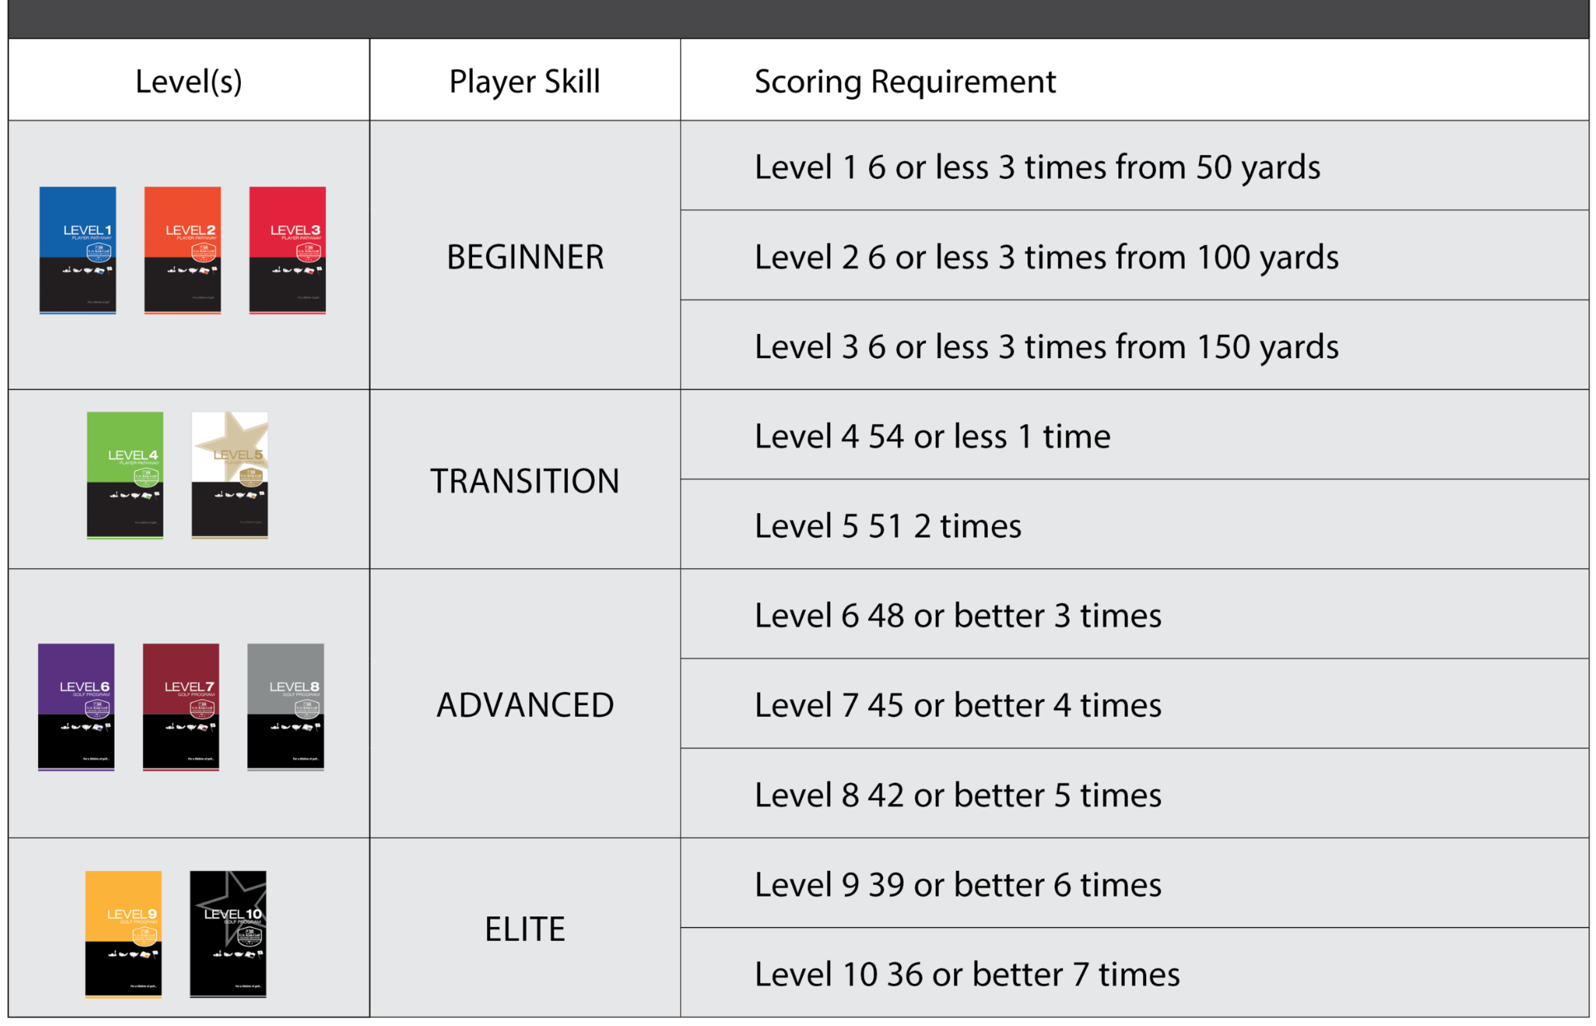

For Parents: The Right Start
The mission of U.S. Kids Golf is to serve families through golf. The belief is that golf is a family game, and every parent is a co-coach in their young player’s journey from beginner to a lifelong golfer. Thus, in order to fulfill the mission, we need to equip every parent with the resources they might need to find their child the right equipment, coach, and also show them how best to engage and support their young golfer as they learn, practice, and ultimately come to love the game of golf. I have demos of many sizes below at LVGC.

Getting Fit For Clubs
U.S. Kids Golf was founded on the principle that properly fit junior golf clubs gives kids the best chance to learn, play, and improve. Measure your player's height in inches with shoes on and select the correct size below to explore each option for your player's specific height. US Kids Golf has 3 club systems to choose from based on the child’s size and abilities: Yard Club (entry level), Ultralight (beginner to intermediate), and Tour Series (intermediate to advanced). Starting at 51" tall and when their driver swing speed surpasses 55 mph, you should consider a move from the Ultralight to the Tour Series clubs.

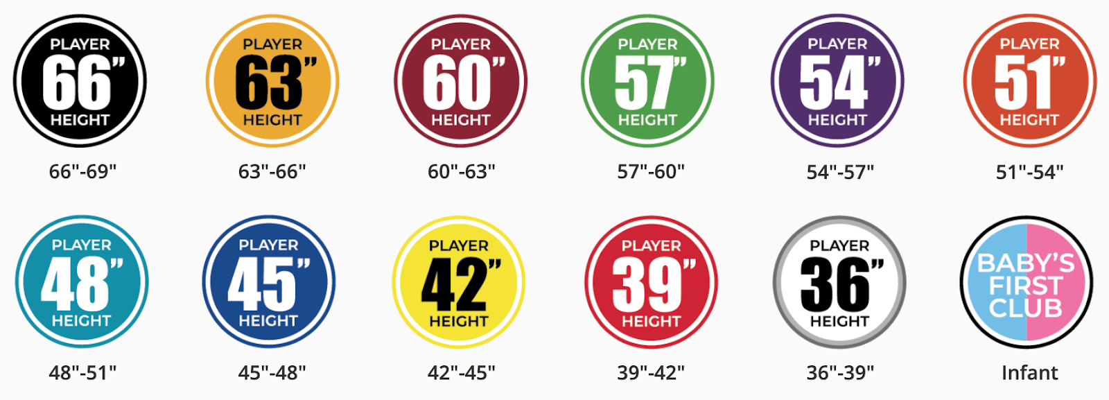
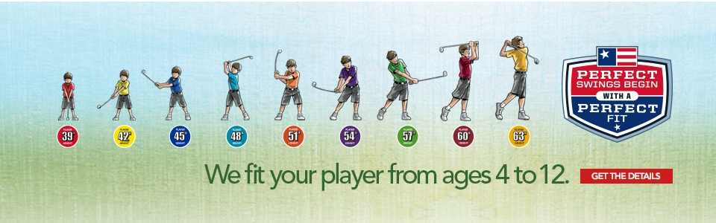
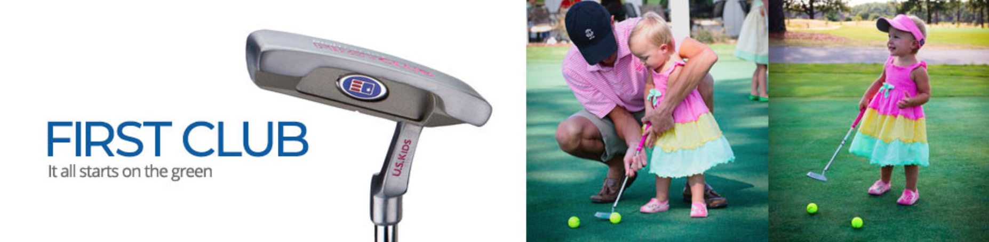

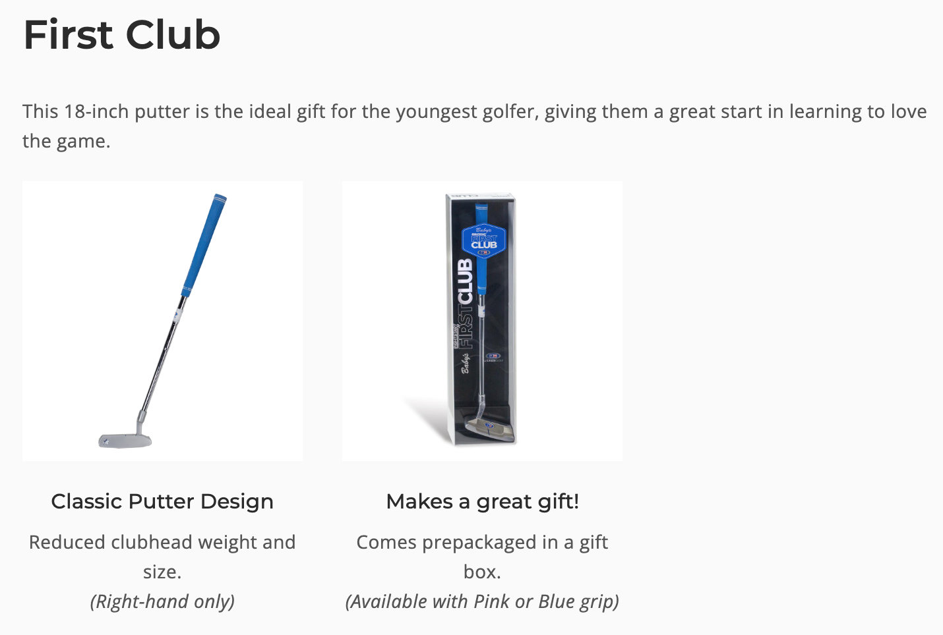

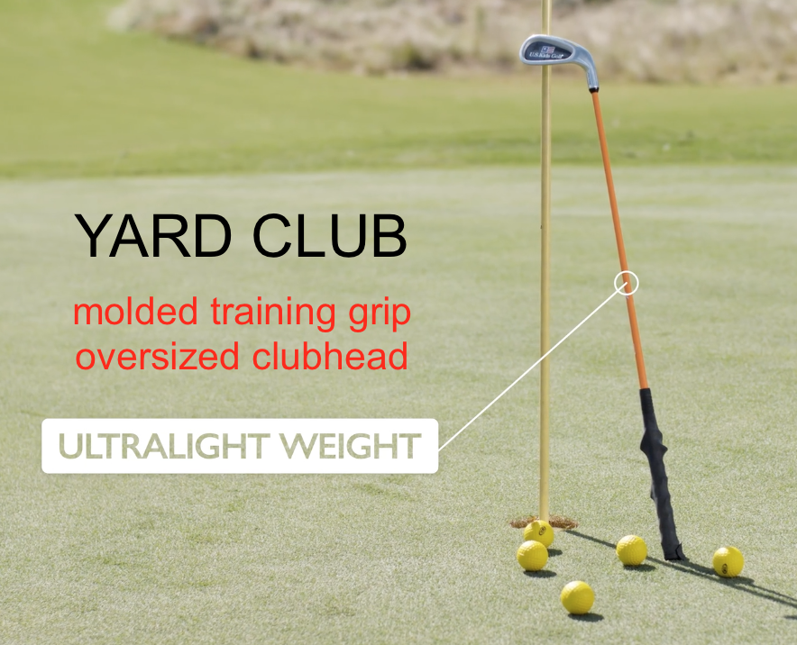

The “Yard Club” (For Junior Golfers who are new to the game of golf)
The perfect choice to get started learning the game, US Kids Golf believes that the Yard Club is the first club beginning players should be given.
With a molded training grip that teaches proper hand placement on the club, an oversized club head and a flexible lightweight shaft that is properly scaled to help your junior develop good swing fundamentals, - this pitching wedge makes learning and developing easier, more fun, and more permanent. It is perfect for use in your yard at home or can be used when training with real golf balls at the driving range or on the golf course.
*NOTE - The Yard Club is not allowed to be used in competition because of the molded grip.
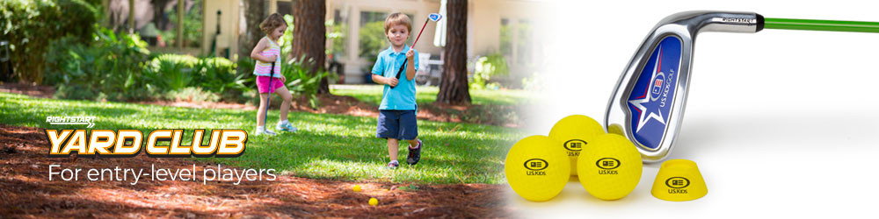

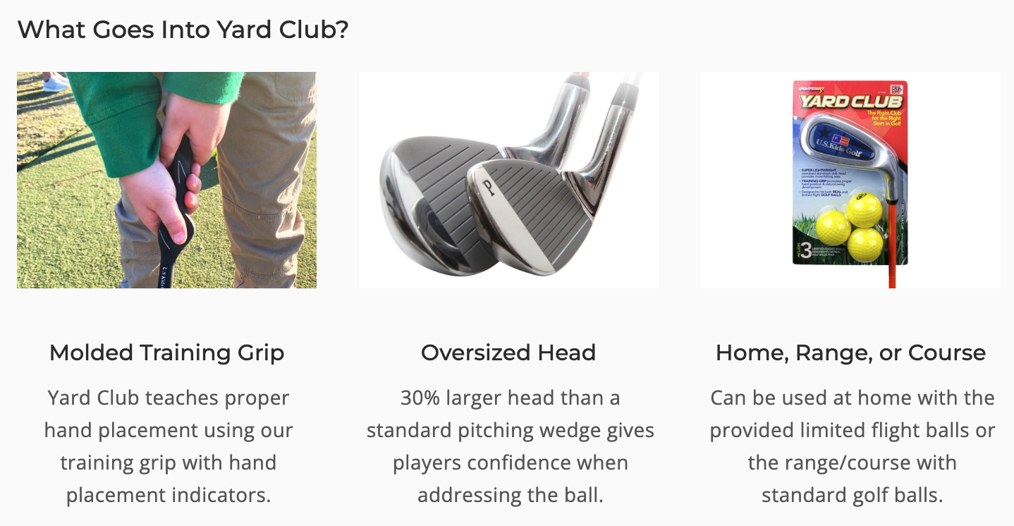

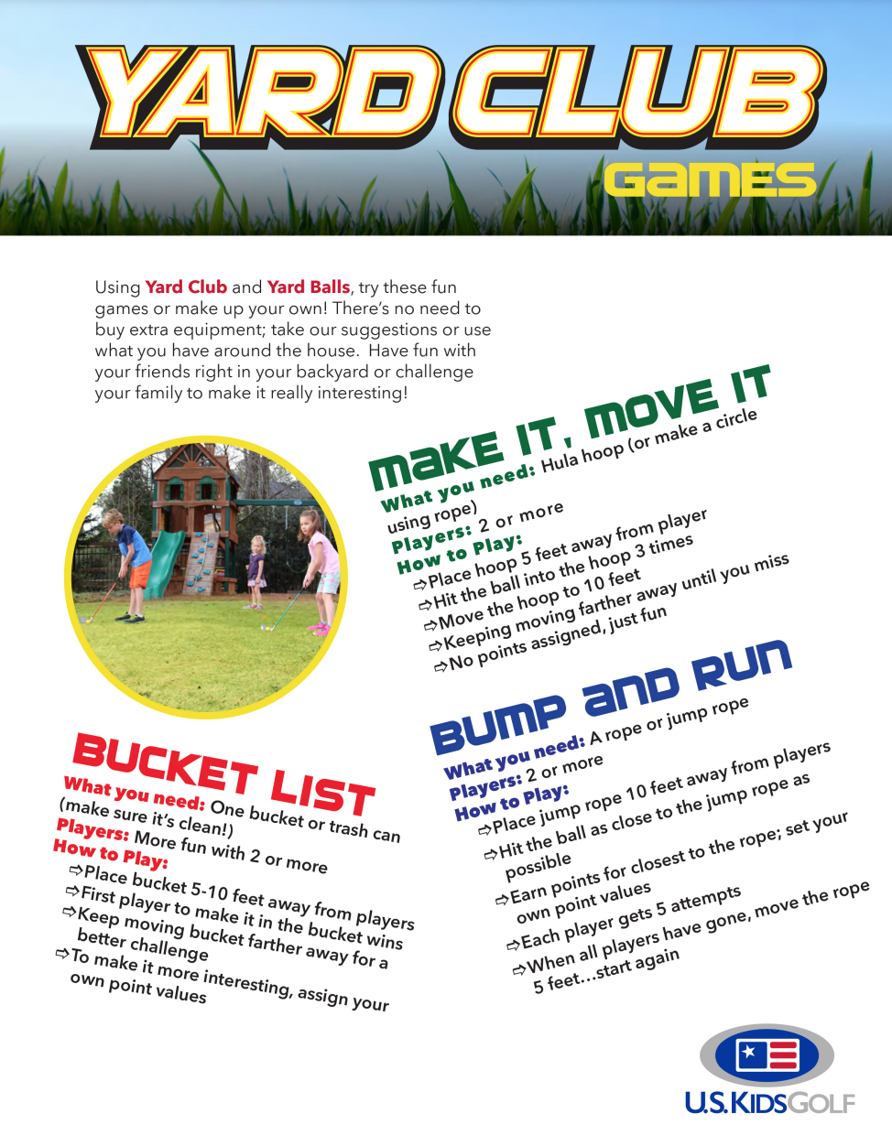

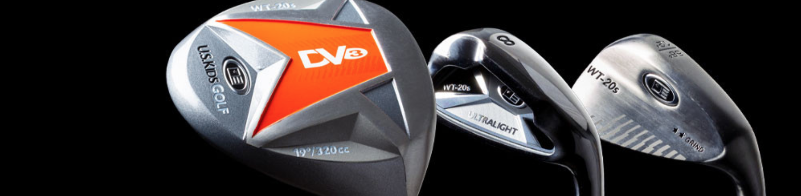

Ultralight (For the Beginning to Intermediate Junior Golfer)
As they have been the best-selling junior golf clubs for more than 20 years, the Ultralight series provides young golfers with clubs that are perfectly fit for their height. Start your junior out with a few individual clubs, or even an entire set, and then you can always add more clubs as your junior’s skills and needs grow. The Ultralight series is available in 9 different sizes.

The Ultralight series is for “beginning to intermediate” junior golfers and is available in 9 unique sizes (player heights 39 inches to 66 inches tall). You can customize your junior golfer’s bag with embroidery for a small upcharge. You can choose your own logo, a personalized name, or a combination of both.

​​Why should you choose the Ultralight Series?

Design:
The Ultralight series is engineered to allow your junior to develop proper fundamentals and lifelong love for the game. It is a progressive system spanning 9 different height ranges. Each size has a unique length, weight, shaft flex, lie angle, and grip size (scaled to match your junior’s size).
Performance:
Ultralight series junior golf clubs make it easier to hit the ball higher, farther, and straighter.
Player Development:
This system ensures young players have equipment that fits their size and game as they continue to develop. At Lakeview GC we have many Ultralight clubs for your child to demo and use before you buy your own clubs, which can be ordered through the Lakeview Golf Club pro shop.
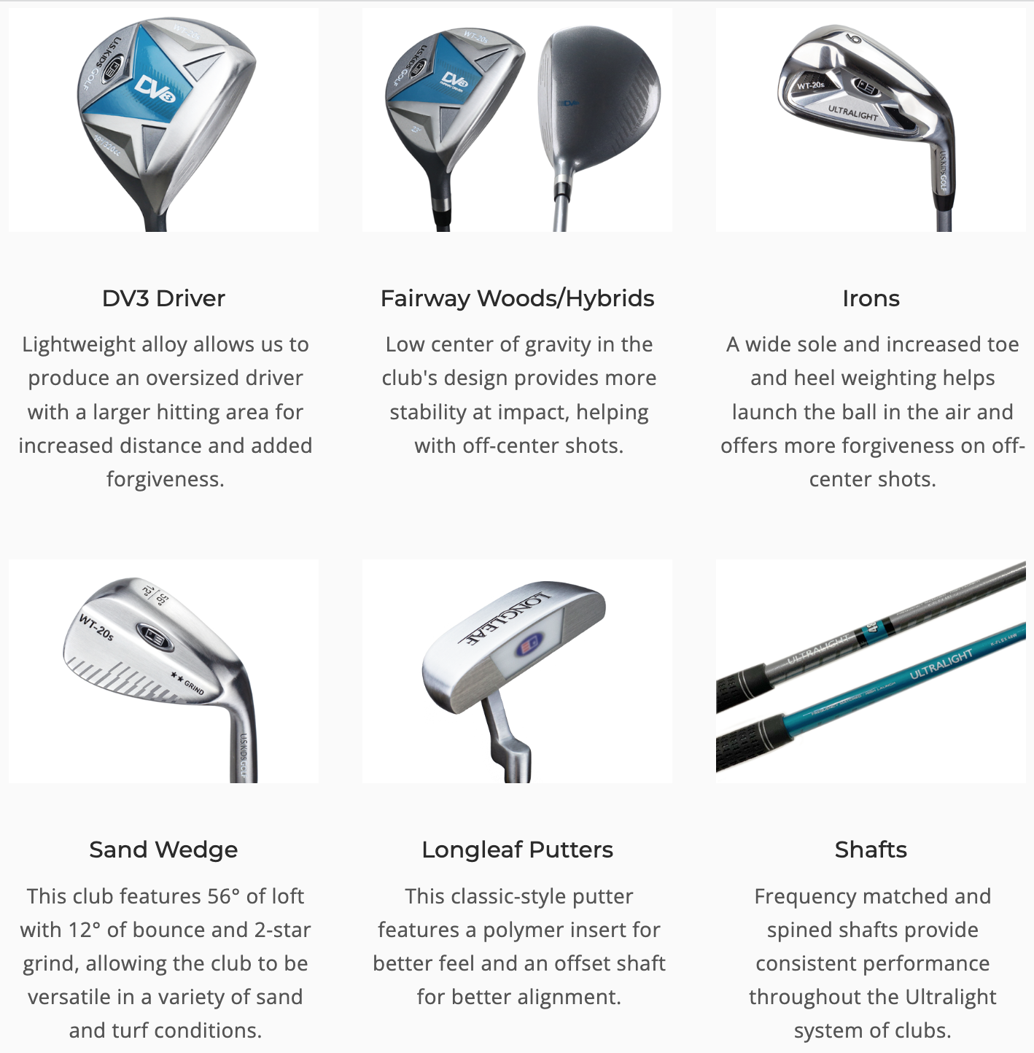

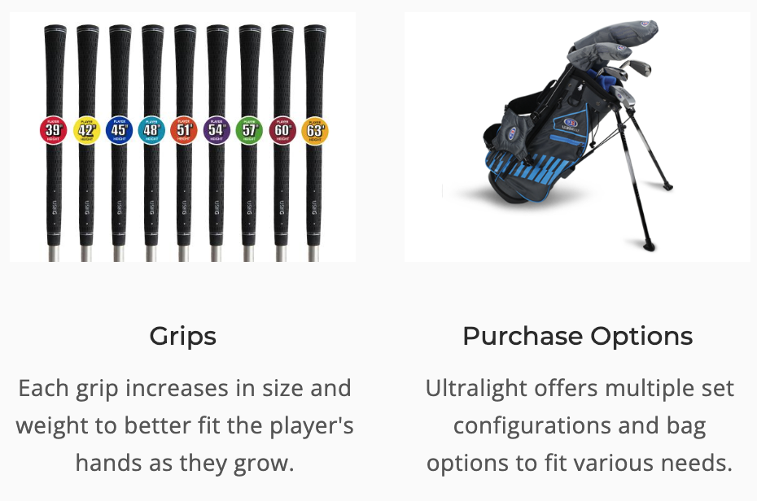

Tour Series (For the Intermediate to Advanced Junior Golfer)
As your junior golfer’s skill level improves, their distance and accuracy can also improve with clubs that have progressively stiffer shafts and heavier clubheads than the Ultralight series. Tour Series is the answer. US Kids Golf has taken the best of adult golf club technology and materials and scaled them into the Tour Series line of equipment. Each size is unique and optimized for the best results in player development. This provides your junior with a pathway forward into adult brands.

When we say Tour Series is a COMPLETE SYSTEM, we mean that every club in each set is created using the highest quality materials, and features consistent swing weights, shaft frequencies, grip sizes, lofts, and lie angles that work TOGETHER within each set. Furthermore, as a player grows in both height and ability, their clubs should match their needs, building on their progression rather than requiring them to create new swing patterns and constantly adjust to new club weights. Moving to a taller size in U.S. Kids clubs too early, or adding a club of another brand to the set such as a longer and heavier driver, causes the player to adjust their swing and technique resulting in slower hand speed and hindering development.

The Tour Series system allows for a junior golfer’s development to be consistent and sustainable throughout their youth. Playing their best now, while building a solid foundation for a future in the game is fundamental to having full and complete trust in their clubs. That’s the Tour Series promise. The chart below can serve as a guide to know when your junior golfer is ready to move up to the Tour Series clubs. Then, once your junior golfer’s driver swing speed reaches 90+ mph, they are likely ready for adult golf equipment - perhaps Senior shafts before Regular Flex.
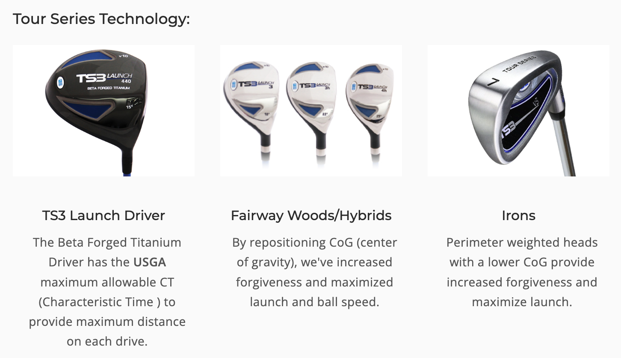
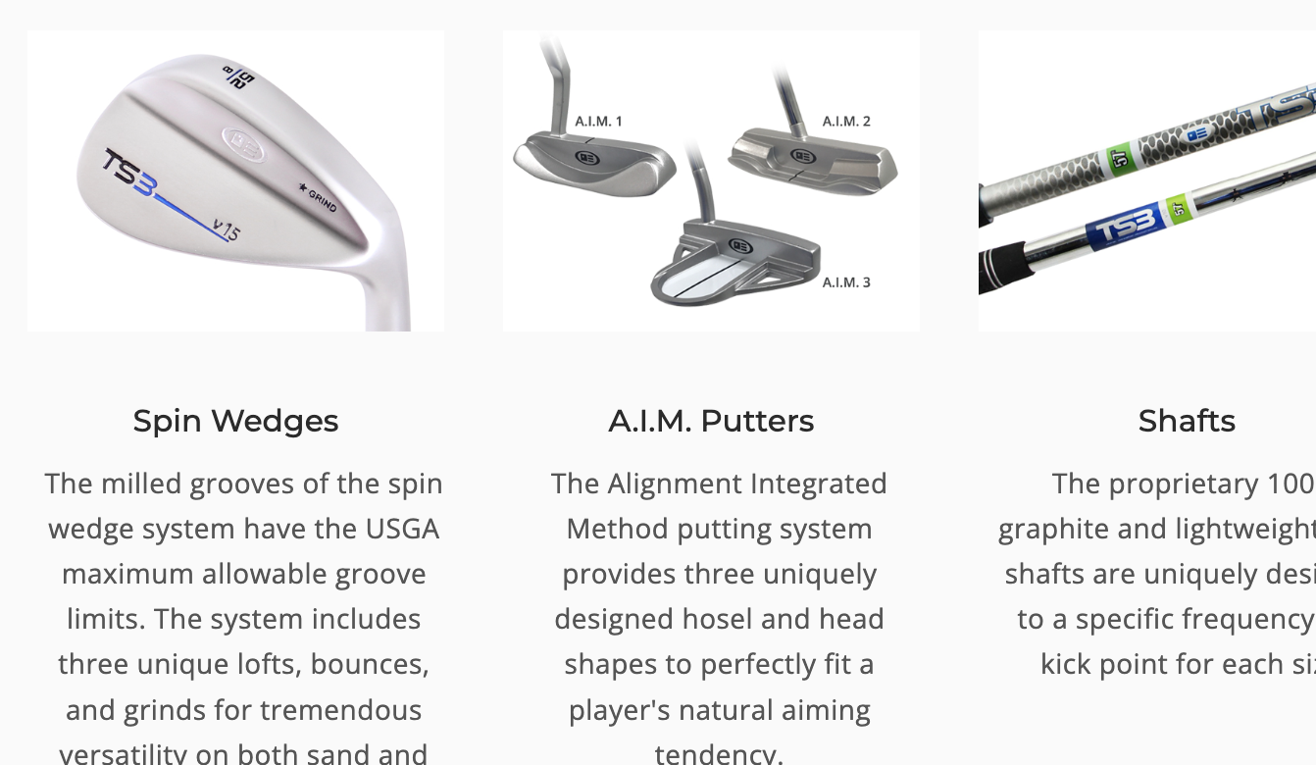

What makes the Tour Series clubs special?

- Quality: Features beta-forged titanium driver; 17-4 stainless fairway woods and hybrids; 431 stainless steel irons; and 8620 satin nickel spin wedges. Choose either 100% graphite or light-weight steel.
- Player Development: Slightly heavier head weights, progressively stiffer shafts, and lower lofts help develop the player's golf game as he or she moves through the six sizes of Tour Series junior clubs.
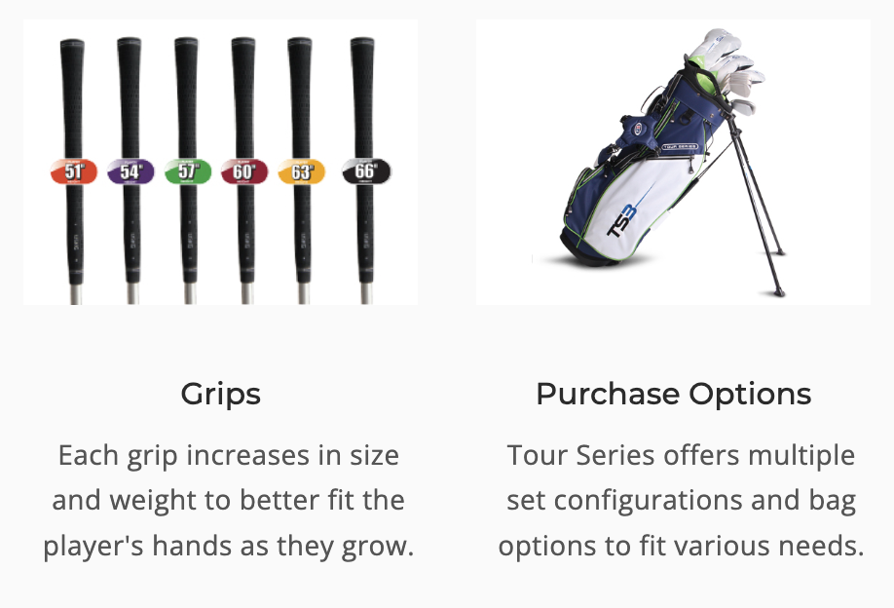

DRIVER SWING SPEED RECOMMENDATIONS

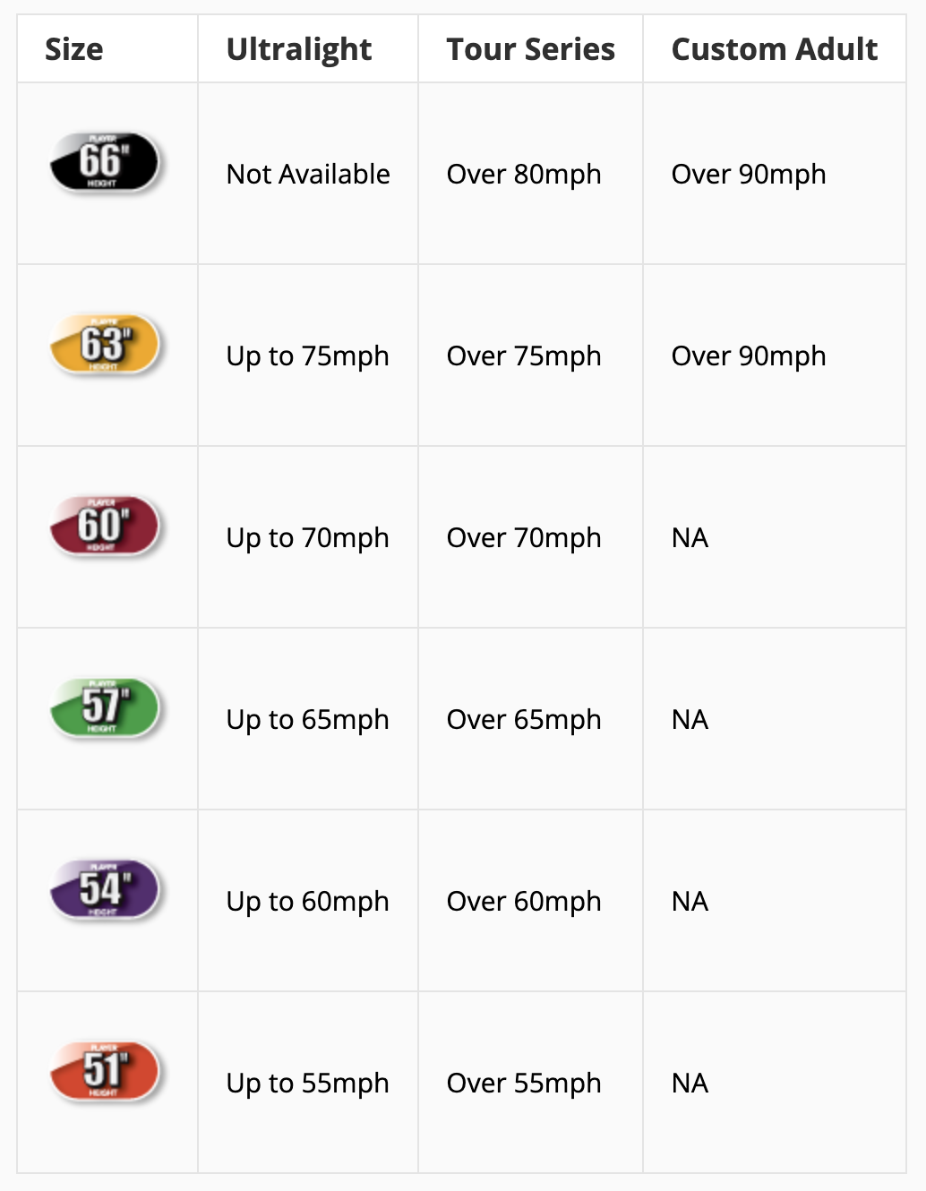
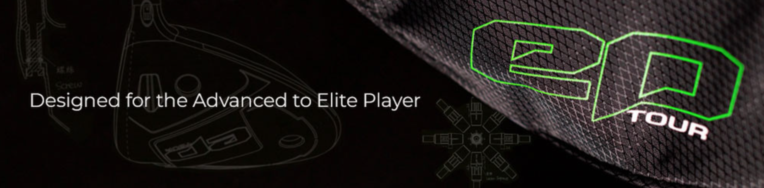

What makes the epTOUR Driver elite?

- 460 cc club head with a Carbon Fiber crown and a Titanium body
- 11⁰ standard loft (adjustable from 9⁰ to 13⁰)
- Shaft adapter with 8 settings allowing for full customization of loft, lie, and face angle
- Driver optimization kit with settings manual, wrench, and additional weights included
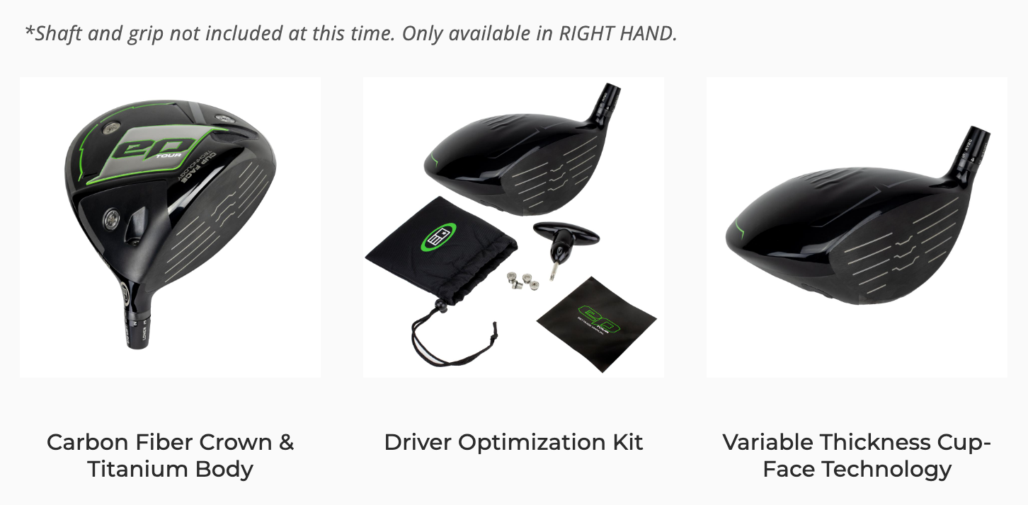

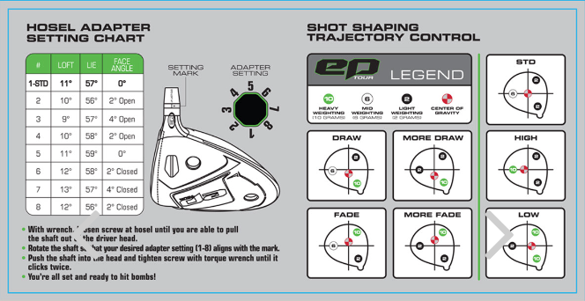

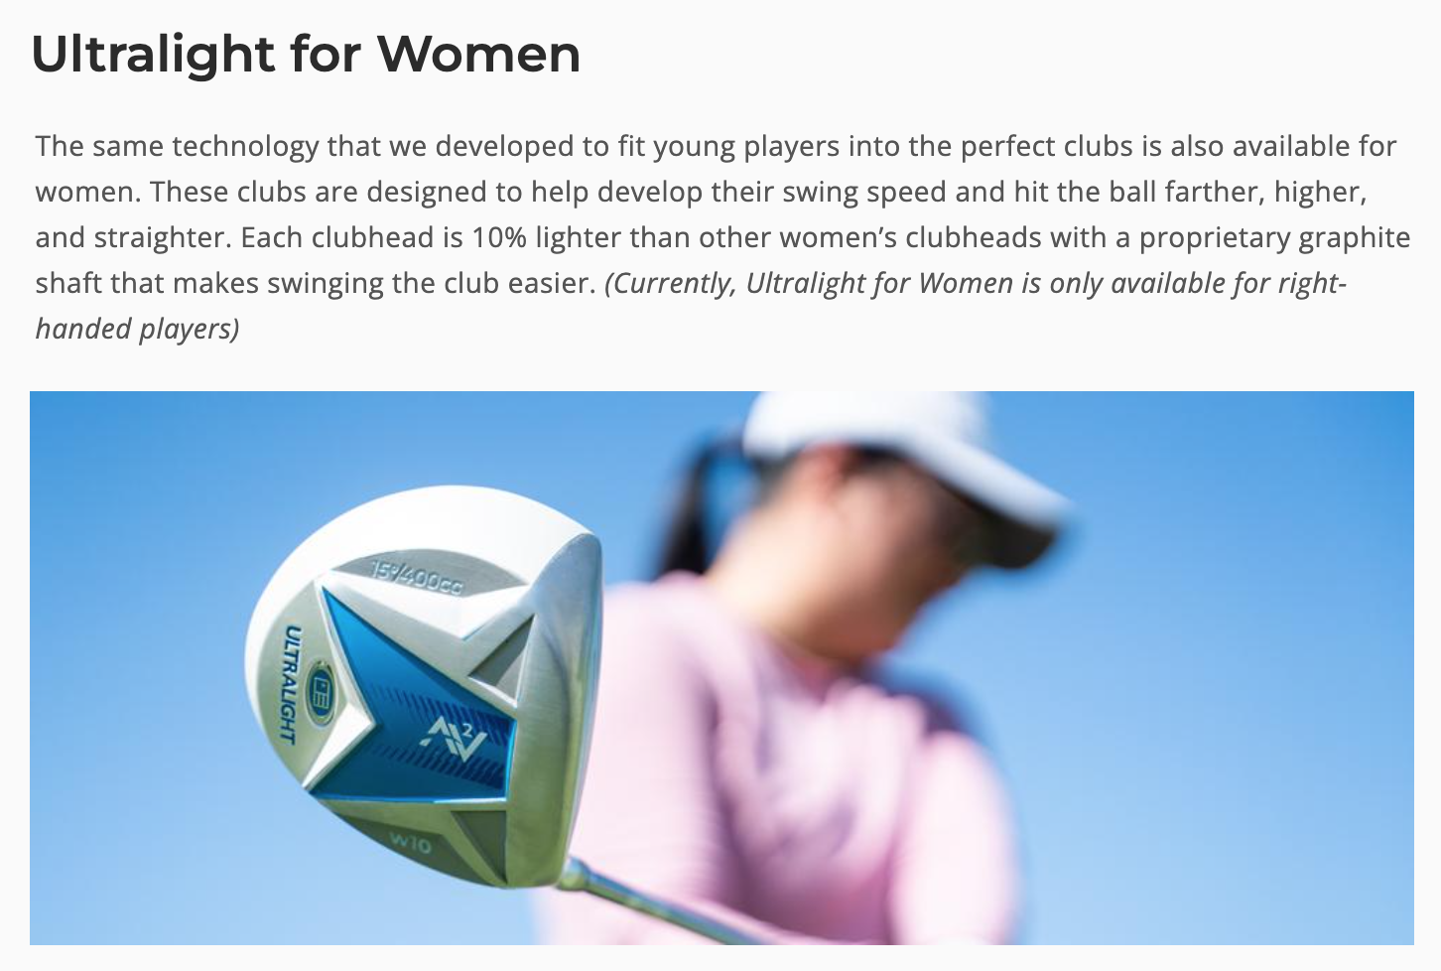
How Will Ultralight for Women Help Your Game?

- Player Enjoyment: Most women's golf clubs are too heavy and too long. The Ultralight Womens’ club system is scaled and designed to be lighter and more flexible. This makes the game more enjoyable and leads to early success in learning the game..
- Design: Ultralight Womens’ clubs are engineered to develop proper fundamentals and lifelong enjoyment of the game.
- Performance: Ultralight makes it easier to hit the ball higher, farther, and straighter.

The Ultralight Women’s Clubs are for beginning to intermediate women playing the game. Available in 2 sizes (60” and 63”) to fit heights from 60” to 66”.
